Choose more sleep over TV, and social media.

Choose more exercise over big pharma chemicals.

Choose more water over carbonated carbohydraty drinks.

More sleep, exercise and water shall benefit you in life.
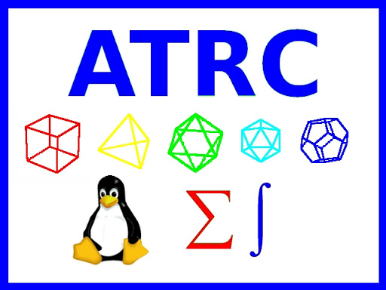
- - Khawar Nehal
15 December 2023
Applied Technology Research Center
http://atrc.net.pk
khawar@atrc.net.pk

