Useless Opportunist :

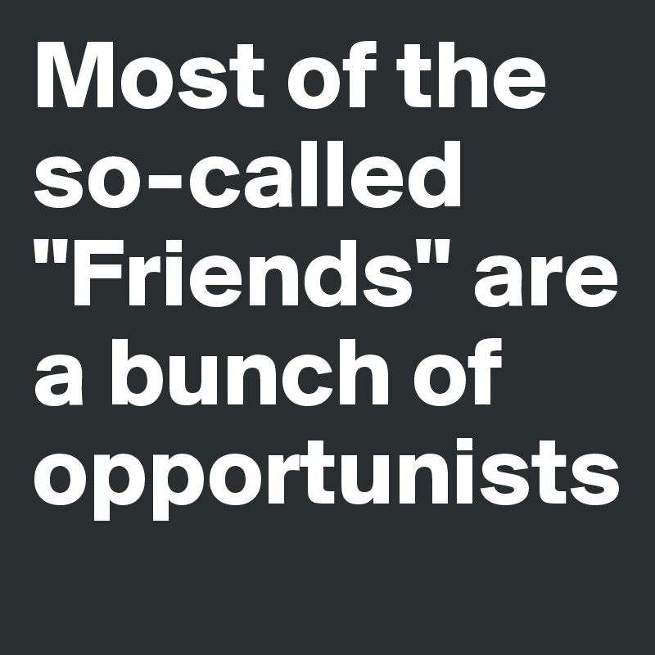
The person knows others for more than ten years and does no work with them on any task, project or business.
When they get wind that someone in their “network” has done something useful, they go running to talk themselves into some partnership in the useful project.
These type of people need to told in no uncertain terms to take a hike for sitting on the sidelines and not participating from the start of the task, project or business.
Maybe they can participate as an outsider in the future if there is some kind of IPO type offer for the public at large.

- - Khawar Nehal
10 Feb 2021

