Steps to Treating Autoimmune Disease
- Check for hidden infections — yeast, viruses, bacteria, Lyme, etc. — with the help of a doctor, and treat them.
- Check for hidden food allergens with IgG food testing or just try to eliminate most food allergens.
- Get tested for celiac disease, which is a blood test that any doctor can do.
- Get checked for heavy metal toxicity. Mercury and other metals can cause autoimmunity.
- Fix your gut.
- Use nutrients such as fish oil, vitamin C, vitamin D, and probiotics to help calm your immune response naturally.
- Exercise regularly — it’s a natural anti-inflammatory.
- Practice deep relaxation like yoga, deep breathing, biofeedback, or massage, because stress worsens the immune response.
- Tell your doctor about Functional Medicine and encourage him or her to get trained.
Give these steps a try — and see if you don’t start feeling less inflamed. Treat the underlying causes of your illness and you will begin to experience vibrant health once more.
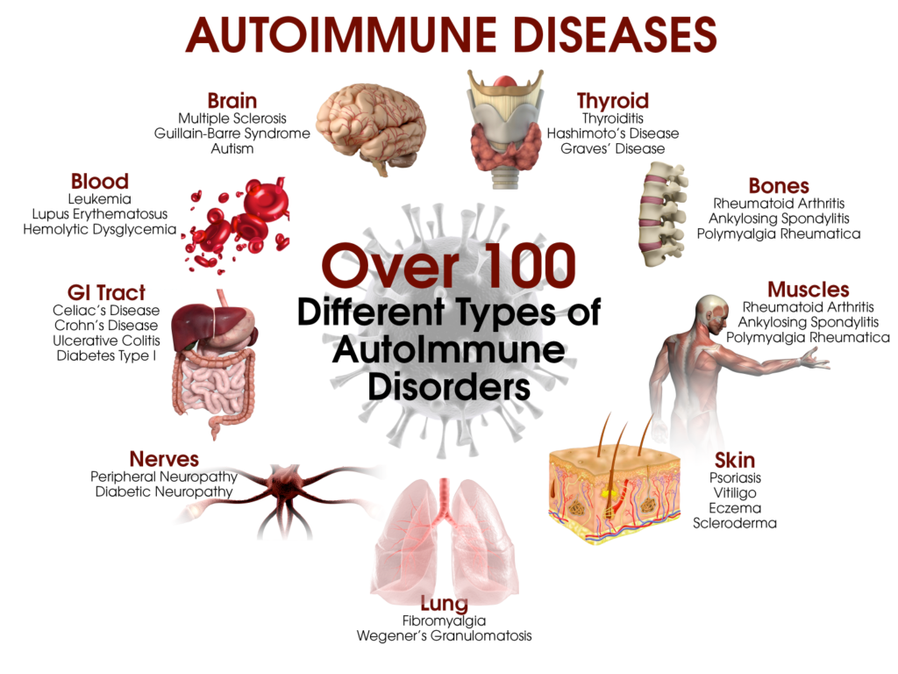

5 Steps to Heal Autoimmune Disease

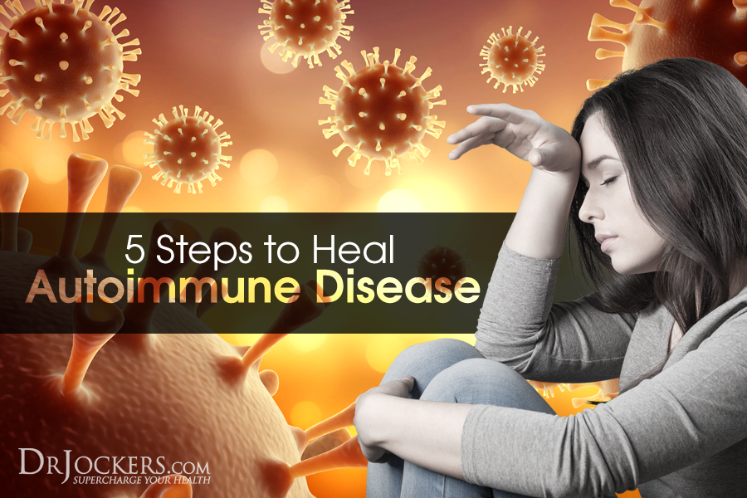

5 Steps to Heal Autoimmune Disease
With the growth of chronic inflammatory conditions, we need more information on strategies to heal autoimmune disease. We live in a world that puts high demands on our bodies to perform and produce all day long. Many of us sacrifice rest in order to strive towards our goals. We stay up late to work, watch movies, surf the web or spend time with family and friends. When our body gives us signs of fatigue, we hit it with caffeine and energy drinks to keep on going strong.
What is the result? We now have an epidemic of people with adrenal fatigue, hormone imbalances, autoimmunity and chronic inflammatory issues. Autoimmune diseases plague over 250 million people all around the world and many more suffer from a wide-variety of chronic inflammatory conditions (1). In this article, you will learn strategies you can take to reduce inflammation and heal autoimmune disease.
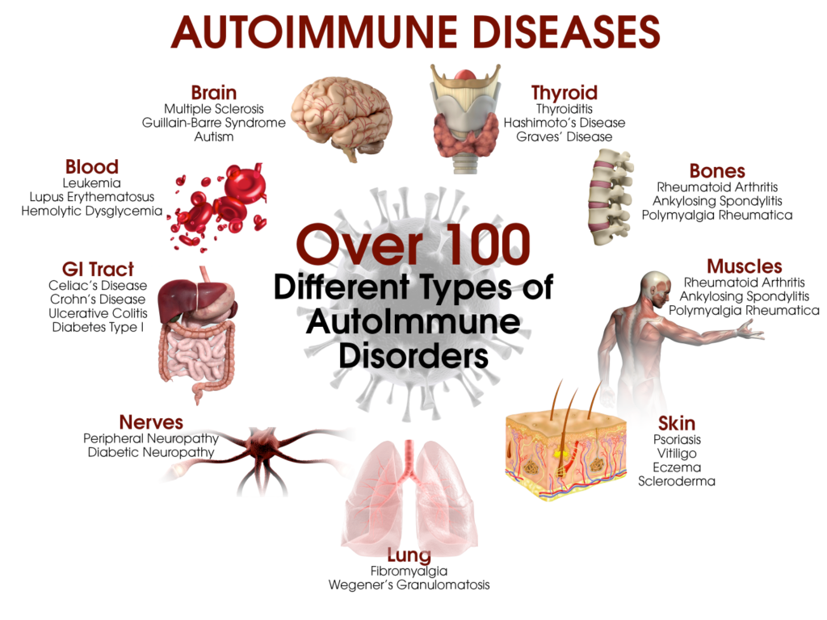

What is Inflammation
Inflammation is a condition where the body’s immune system attack various proteins that are seen as foreign and potentially dangerous to the body. This includes things that really could be dangerous such as bacteria, viruses, parasites, etc. But it can also include things that aren’t dangerous to the body such as pollen, dust, specific food particles and our own tissues.
Acute inflammation, such as when we have a splinter, is necessary in order to prevent against a dangerous infection. The inflammatory storm that takes place when we have an open wound is nothing short of life-saving.
In fact, systemic infections have killed more people in the history of mankind than anything else. So the body has adapted to become stronger over time and we have hardwired the inflammatory storm process to allow us to survive dangerous infections. Unfortunately, this same strong internal military can be untamed and cause damage and destruction to our tissues.
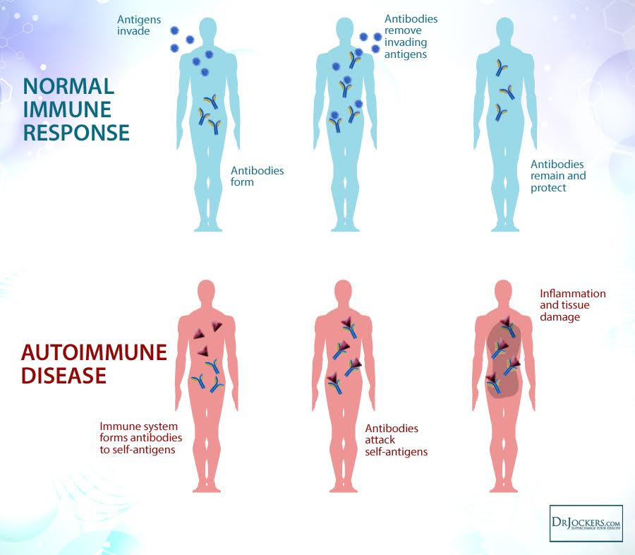

Chronic Inflammation vs. AutoImmunity
Chronic inflammatory processes and autoimmunity have a lot of similarity but also some differences. Autoimmunity is usually associated with an overall chronic inflammatory process. However, one could have a chronic inflammatory condition without having autoimmunity.
A chronic inflammatory process is when some sort of trigger (pollen, food particles, etc) initiates a strong inflammatory process that causes collateral damage to other tissues of the body such as the gut lining, blood vessels, the sinuses, the lungs, the joints, etc. This would create conditions such as inflammatory bowel disease, heart disease, allergies, asthma, osteoarthritis, etc.
An autoimmune condition is when the bodies white blood cells produce a specific antibody to target a particular tissue or enzyme within a tissue of the body. For example, in Hashimoto’s thyroiditis the body will produce an anti-body to attach certain enzymes such as thyroid peroxidase or thyroglobulin that work to produce thyroid hormone.
So the big difference between chronic inflammatory conditions (CIC) and autoimmunity is that in CIC’s we have tissue damage resulting as an indirect effect of the inflammatory process. While in autoimmunity we see tissue damage as a direct effect of the inflammatory process.
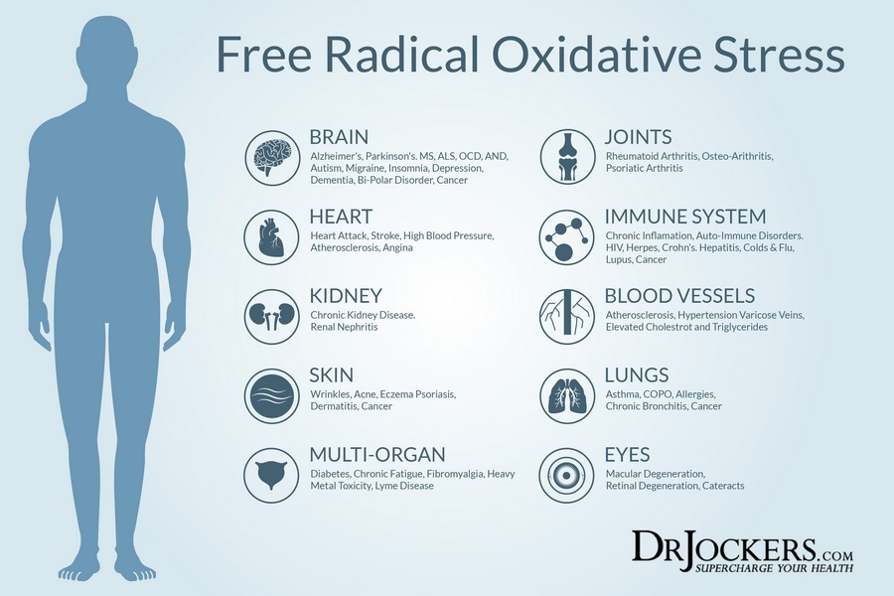

Establishing Immune Tolerance
The key to reducing inflammation and autoimmunity is to improve the immune coordination within our body in order to establish immune tolerance. Immune tolerance is where the body is able to effectively discriminate against self vs. non-self tissue and is able to create a more precise inflammatory process so as to not have significant collateral tissue damage (2).
The immune response is a remarkable network that depends upon trillions of unique enzymes, proteins and cell receptors to communicate and adapt at any given moment. This allows for a steady acclimation to the constant alterations in the environment in order to give the body the best chance for survival.
Healthy immunity is dependent upon good communication and proper regulatory patterns in the immune system. This is the biological process that must take place to heal autoimmune disease.
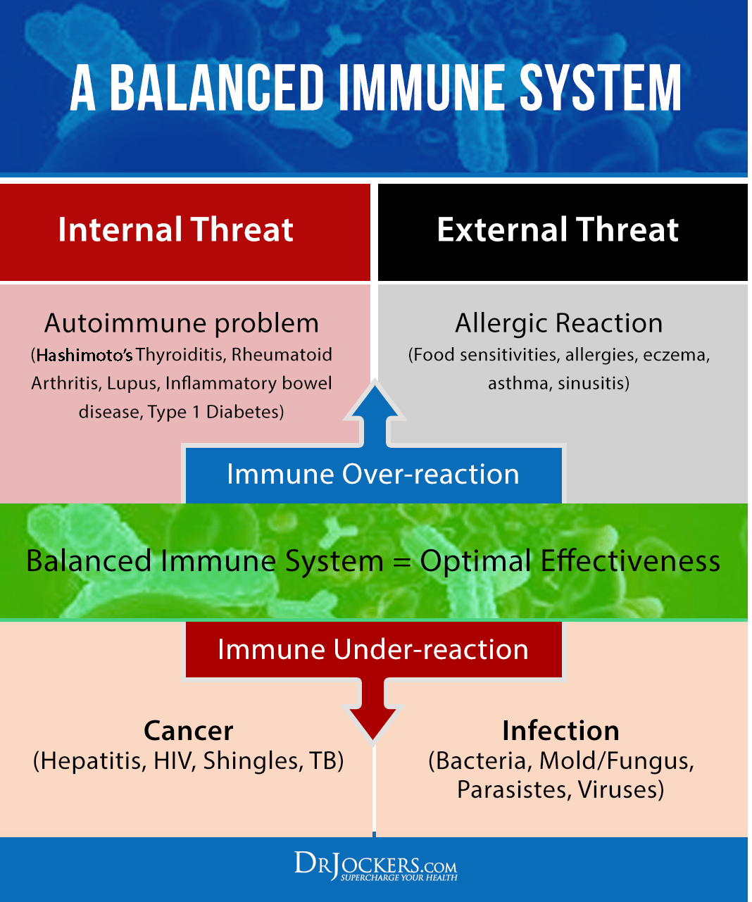

Regulatory T Cells
The body has a very intelligent cell called the T regulatory cell which is produced in the thymus. This results in the body having the appropriate balance of T cells where we have the proper ratio of T helper, cytotoxic T cells, killer T cells and T suppressor cells.
One test used to look at this balance is the CD4:CD8 test. T helper cells are in the CD4 category and the T suppressor cells are in the CD8 category. Looking at this balance helps to understand how immune tolerant the body is (3).
When the body has elevated T helper, cytotoxic and killer T cells, we have an increased risk of developing chronic inflammatory conditions and autoimmunity. On the flip side, if the body has elevated immune suppressor cells, the immune system lacks punch and the individual may be more susceptible to infection.
Fortunately, there are many lifestyle strategies we can take to maintain T cell balance and immune tolerance.
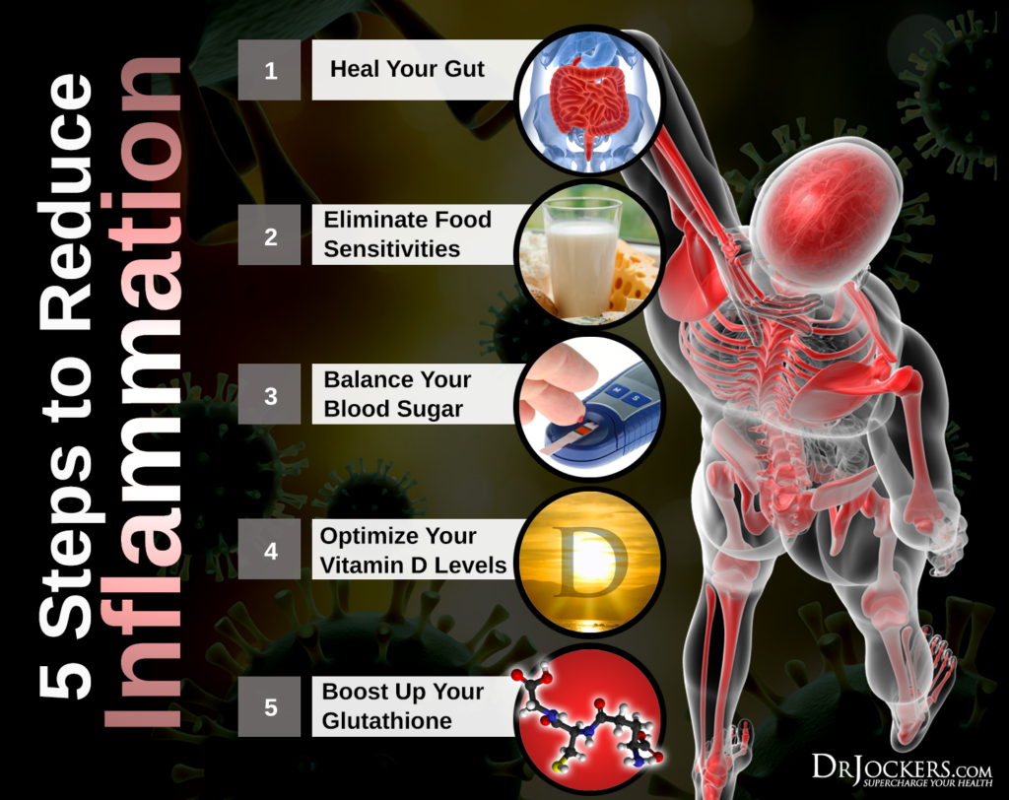

5 Steps to Reduce Inflammation
Here are the best action steps to get started with on your journey to prevent and/or heal chronic inflammation and autoimmune disease. You should always consult with your physician before stopping or changing medications or taking on new health strategies.
Additionally, you should be working with a functional health practitioner to help guide you through these strategies. This is not an exhaustive list and there are other natural therapeutic strategies that I and functional health practitioners will utilize to help individuals with chronic inflammation and autoimmune disorders.

1. Heal Your Gut
Intestinal permeability or leaky gut syndrome is a condition where the intestinal lining is damaged. The damage to the gut lining opens up the intestinal junctions and allows for large food particles, bacteria and environmental toxins to seep into the blood stream.
When the immune system recognizes that bacteria and large undigested food particles are in the blood stream, it will go on high alert, as this could be a life threatening risk. So the body initiates a chronic inflammatory process in order to reduce the bacteria, toxic debris or food particles in circulation.
Keeping the gut lining healthy is of upmost importance to establishing immune tolerance and heal autoimmune disease (4). In this article, I go over the top 10 foods to heal leaky gut. You will never heal autoimmune disease until you get the gut lining stable.
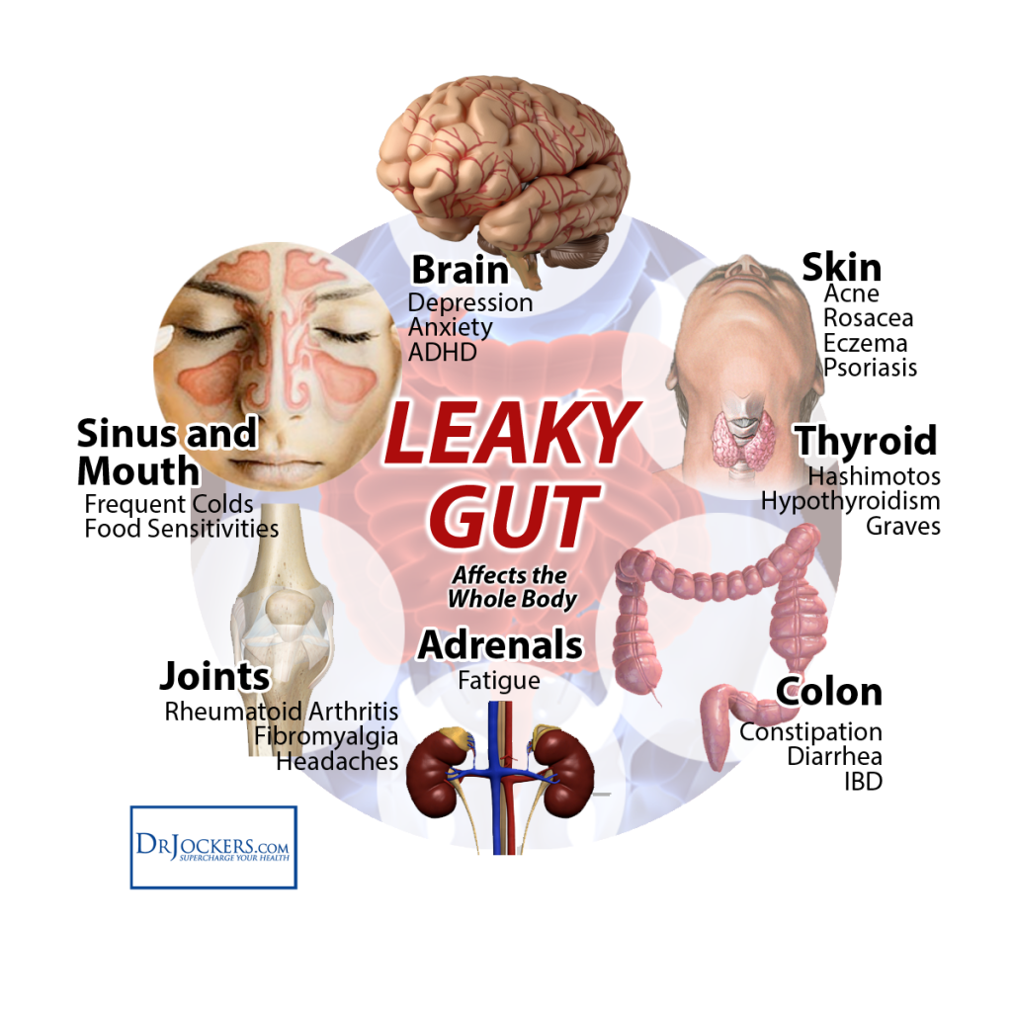

2. Eliminate Food Sensitivities
Food sensitivities come about due to leaky gut syndrome and cause an inflammatory process within the gut when we consume them. This inflammatory process further damages an already inflamed gut and creates a worsening condition of intestinal permeability.
As the gut lining gets even more damaged, more bacteria and protein molecules are released into the blood stream causing amplified inflammation throughout different regions of the body. In order for one to create immune tolerance, they will need to eliminate their food sensitivities for an undisclosed period of time (5).
This is called an elimination diet. An elimination diet is simply a nutrition plan that eliminates the most common foods that contribute to inflammation along with other susceptible foods. As you follow this for a period of time, the level of inflammation reduces and the body is able to repair and heal itself. This is a critical strategy to heal autoimmune disease. This article goes over 5 steps to following an elimination diet.
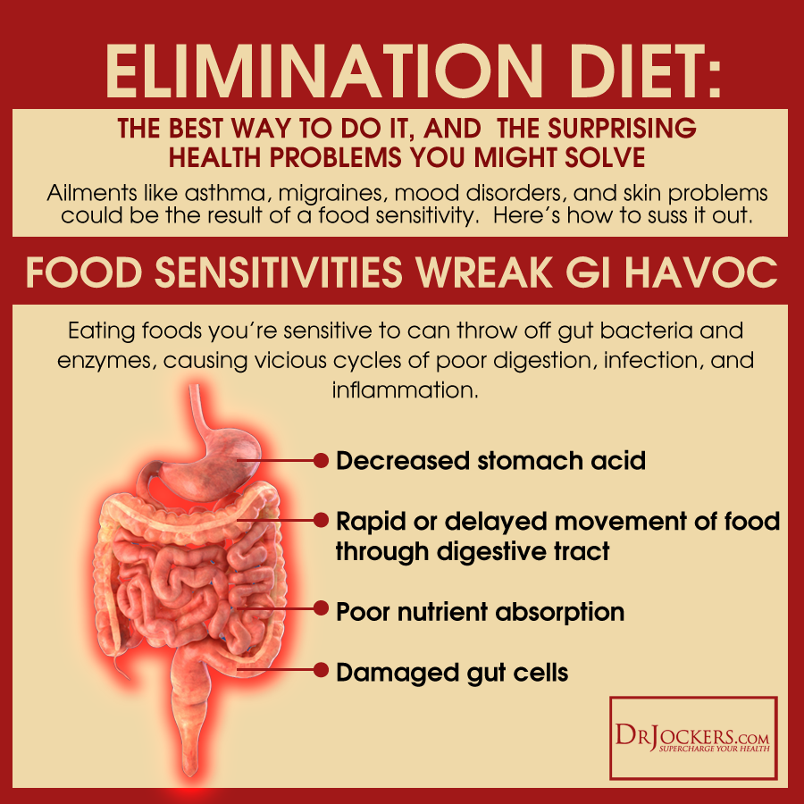

3. Balance Your Blood Sugar
Blood sugar stability plays a huge role in the inflammatory process. One of the most powerful anti-inflammatory compounds within the body is the stress hormone cortisol. Cortisol is called a glucocorticoid because it’s primary role is to mobilize glucose.
The antagonist to cortisol is insulin, which takes glucose and puts it into cells. Insulin also has a pro-inflammatory nature, so that the higher the blood glucose, the increased need for insulin and the more inflammatory activity will be produced (6).
Elevated blood sugar also reduces the strength and tone of the immune system. When the immune system loses its tone, it favors chronic inflammation as a way of prioritizing survival.
When we have blood sugar imbalances, we cycle through periods of both high and low blood sugar. Low blood sugar, signals cortisol levels. Overtime the body becomes resistant to both insulin and cortisol and we end up with increased inflammatory activity (7).
This article goes into detail on advanced strategies to stabilize your blood sugar levels. This is a foundational step to heal autoimmune disease.
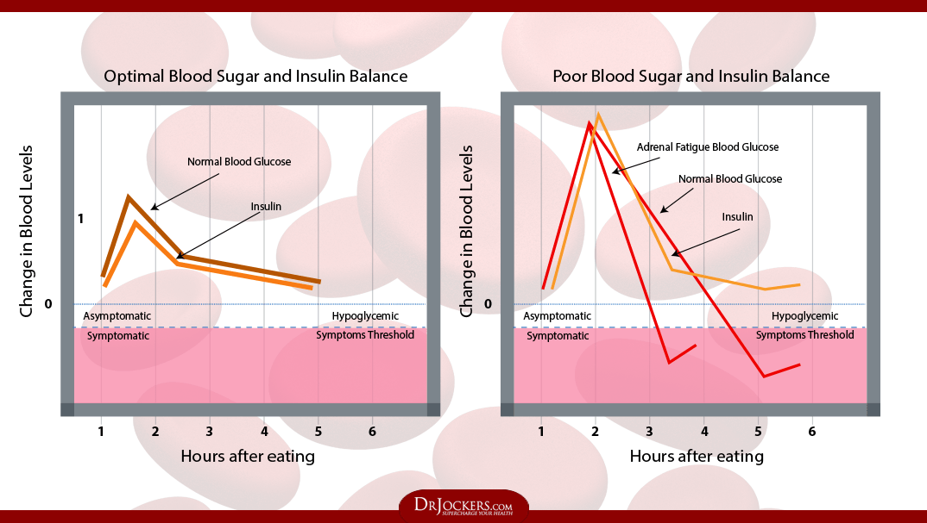

4. Optimize Your Vitamin D Levels
Vitamin D is considered to be more of a hormone than a vitamin based around its role in the body. Hormones are chemical messengers that communicate with cell receptors to produce specific biological responses in the body. In this way, calcitriol, which is the active form of vitamin D, has the ability to activate over 1,000 genes in the body (8).
All the major immune cells have vitamin D receptors and these immune cells are all capable of synthesizing the active vitamin D metabolite. Vitamin D modulates the balance between the innate and adaptive immune responses. Studies have shown that vitamin D deficiencies are associated with increased autoimmune development and increased susceptibility to infection (9, 10).
This article goes into more of the benefits of vitamin D and the best strategies to optimize your levels. You must optimize vitamin D levels to heal autoimmune disease!
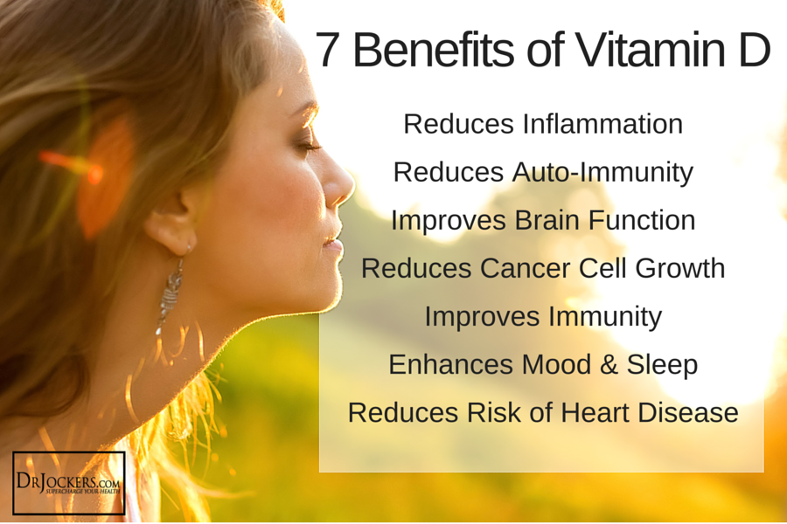

5. Boost Up Your Glutathione
Glutathione is considered the “master anti-oxidant” within the body and is produced by every cell in the body where it functions to protect our DNA. Glutathione is our cell’s security guard that protects the cellular components from outside free radical attack. Longevity scientists now believe that the level of glutathione in our cells has a direct relationship with how long we will live (11,12).
Glutathione plays a very important role in establishing immune tolerance (13). Studies have demonstrated that glutathione enhances the function of T cells and modulates immune activity (14). In this way, optimizing glutathione levels are extremely important for reducing collateral damage associated with inflammation and autoimmune reactions (15).
This article goes into more detail on glutathione and its role in reducing inflammation. This article here goes into 5 key nutrients needed to heal autoimmune disease. Hopefully, this article has given you hope and several major action steps to reduce inflammation and heal autoimmune disease.
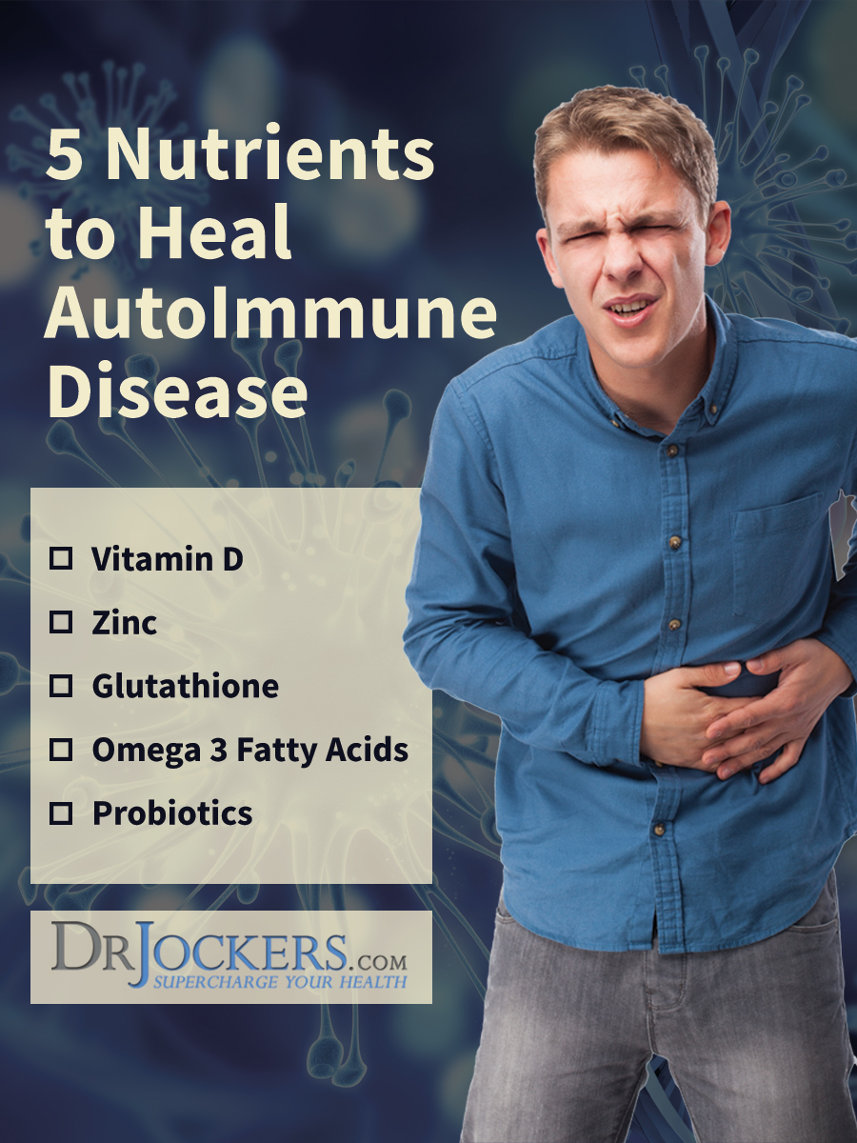

Sources For This Article Include:

1. Schmidt CW. Questions Persist: Environmental Factors in Autoimmune Disease. Environmental Health Perspectives. 2011;119(6):A248-A253.

2. Mackay IR. Tolerance and autoimmunity. Western Journal of Medicine. 2001;174(2):118-123.

3. Uppal SS, Verma S. Analysis of the clinical profile, autoimmune phenomena and T cell subsets (CD4 and CD8) in Takayasu’s arteritis: a hospital-based study. Clin Exp Rheumatol. 2003 Nov-Dec;21(6 Suppl 32):S112-6. PMID: 14740436

4. Fasano A. Leaky gut and autoimmune diseases. Clin Rev Allergy Immunol. 2012 Feb;42(1):71-8. PMID: 22109896

5. Manzel A, Muller DN, Hafler DA, Erdman SE, Linker RA, Kleinewietfeld M. Role of “Western Diet” in Inflammatory Autoimmune Diseases. Current allergy and asthma reports. 2014;14(1):404.

6. Shoelson SE, Lee J, Goldfine AB. Inflammation and insulin resistance. Journal of Clinical Investigation. 2006;116(7):1793-1801.

7. Collier B, Dossett LA, May AK, Diaz JJ. Glucose control and the inflammatory response. Nutr Clin Pract. 2008 Feb;23(1):3-15. PMID: 18203960

8. Genetic and epigenetic studies on Vitamin D Link Here

9. Aranow C. Vitamin D and the Immune System. Journal of investigative medicine : the official publication of the American Federation for Clinical Research. 2011;59(6):881-886.

10. Agmon-Levin N, Theodor E, Segal RM, Shoenfeld Y. Vitamin D in systemic and organ-specific autoimmune diseases. Clin Rev Allergy Immunol. 2013 Oct;45(2):256-66. PMID: 23238772

11. Richie JP Jr, Leutzinger Y, Parthasarathy S, Malloy V, Orentreich N, Zimmerman JA. Methionine restriction increases blood glutathione and longevity in F344 rats. FASEB J. 1994 Dec;8(15):1302-7. PMID: 8001743

12. Glutathione – A closer look at the master antioxidant Link Here

13. Dröge W, Breitkreutz R. Glutathione and immune function. Proc Nutr Soc. 2000 Nov;59(4):595-600. PMID: 11115795

14. Chang WK, Yang KD, Chuang H, Jan JT, Shaio MF. Glutamine protects activated human T cells from apoptosis by up-regulating glutathione and Bcl-2 levels. Clin Immunol. 2002 Aug;104(2):151-60. PMID: 12165276

15. Perricone C, De Carolis C, Perricone R. Glutathione: a key player in autoimmunity. Autoimmun Rev. 2009 Jul;8(8):697-701. PMID: 19393193

